**RESUME OF R.P. KASUN CHANDULA ABEYSEKARA**

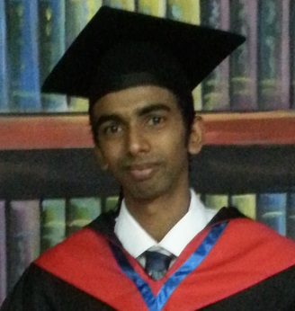

1. **PERSONAL INFORMATION**

* Name In Full - Rankiri Pathiranalage Kasun Chandula Abeysekara
* Date of Birth - 1988.11.25
* Age - 25 Years Old
* Gender - Male
* Marital Status - Single
* Nationality - Sri Lankan
* NIC No. - 883303377V
* Passport No - N0882095
* Languages - English & Sinhala
* Permanent Address - No. 58, Rawathawatta Road,Moratuwa,Sri Lanka
* Contact Number - 0112655189 / 0771661301
* E-Mail - kasunchandula1988@gmail.com

1. **EDUCATIONAL QUALIFICATIONS**

**School Attended – St. Sebastian’s College. Moratuwa**

* **Passed The G.C.E. (O/L) Examination Held in December 2004**

**Subject**  **Grade**

* English B
* Social Studies B
* Roman Catholic C
* Sinhalese language C
* Health Education C
* Mathematics S
* Commerce S
* Science S
* **Passed The G.C.E. (A/L) Examination Held in August 2008**

**Subject**  **Grade**

* Roman Catholic C
* Sinhalese Language S
* Political Science S
* General English C

**University Attended – Lincoln University (Malaysia)**

* Studied as a Hotel & Catering Student (Diploma)
* University Period - 2010 – 2013
* In 2013 graduated

1. **OTHER EDUCATIONAL QUALIFICATIONS**

* I have followed a Computer Course in IDM, Sri Lanka
* I have followed English Courses in British Council, Sri Lanka
* I have successfully passed IELTS examination (Academic)

1. **CURRICULAR ACTIVITIES AND QUALIFICATIONS**

* Member of R&D Pool club
* Member of the Youth club

1. **REFEREES**

Mrs. N.D. Ariyarathne

Vice President

Lanka Jathika Sarvodaya Movement

98, Rawathawatta Road,

Moratuwa.

Tel: 0112655084 / 0112655255

* I hereby certify that all the above particulars are true and accurate to the best of my knowledge
* If I am selected, I assure that I will discharge all the assigned duties to the best of ability and to the entire satisfaction of the management

…………………………………………….. ……………………………………………….

Date Signature